**Simulation results to accompany:**

Preacher, K. J., Zhang, Z., & Zyphur, M. J. (in press). Multilevel structural equation models for assessing moderation within and across levels of analysis. *Psychological Methods*.

Here we report the results of three targeted simulation studies comparing the use of LMS to observed cluster means (termed UMM for “unconflated multilevel model” in Preacher et al., 2011) rather than latent cluster means.

**Simulation 1**

The first simulation uses the following conditions:

No. of clusters: 50, 100, 200

Cluster size: 5, 10, 20

Hypothesis: B2 (interaction of L2 variable with latent cluster mean of a L1 variable)

ICC: ICC = .5 for *xij*

Effect size: Interaction effect = .2

Simulation reps: 500 per cell

For each of the 18 cells of the design, we examined bias in the estimate (mean estimated interaction effect vs. the true value of .2) and bias in the estimated standard error (mean estimated *SE* vs. the empirical standard deviation [ESD] of the estimate across reps). All 500 reps converged for all cells of the design. The following tables summarize the results:

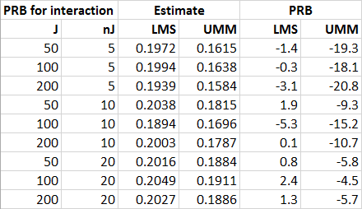

*Note*. PRB = percent relative bias; LMS = latent moderated structural equations; UMM = unconflated measured manifest means; *J* = number of clusters; *nJ* = cluster size.

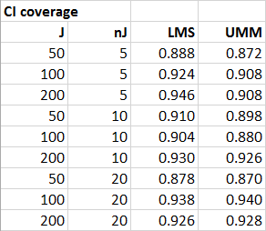 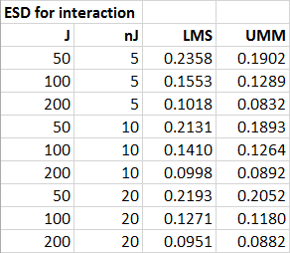

*Note*. ESD = empirical standard deviation.

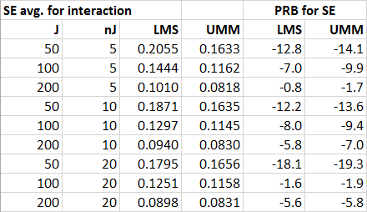

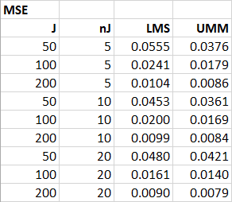

*Note*. MSE = mean squared error.

To summarize the results, LMS is superior in terms of minimizing bias and achieving more accurate CI coverage, whereas UMM is superior in terms of efficiency. UMM also appears superior in terms of MSE (the combination of bias and sampling variance), but this is largely due to UMM’s greater underestimation of its ESD (see “PRB for SE” columns).

UMM approaches LMS’s performance in terms of bias and CI coverage more closely as the sample size increases, as would be expected from prior research comparing these methods in other contexts (e.g., Preacher et al., 2011). However, under the limited conditions examined, bias never reached acceptable levels for UMM. On the basis of our results, MSEM with our proposed LMS method is arguably superior to the prevailing popular method of using observed cluster means. Note that our simulations used a predictor ICC of .5, which is quite high. The relative performance of UMM will suffer more as ICC decreases to levels more commonly encountered in practice (Preacher et al., 2011). These results mirror similar simulation results presented by Preacher et al. (2011) and Lüdtke et al. (2008), and serve to support our contention that our recommended LMS approach may be useful for researchers in practice.

**Simulation 2**

To investigate the costs of unbalanced cluster sizes, we repeated our simulation with a modification. We used the same conditions as before, including the same total sample sizes, but arrived at these total sample sizes using unbalanced clusters. For instance, rather than 50 clusters of size 5, we used 20 clusters of size 2, 18 clusters of size 5, and 10 clusters of size 12 (other conditions used this same cluster ratio of 20:18:10 to maintain consistency across cells). All 500 reps converged in each condition.

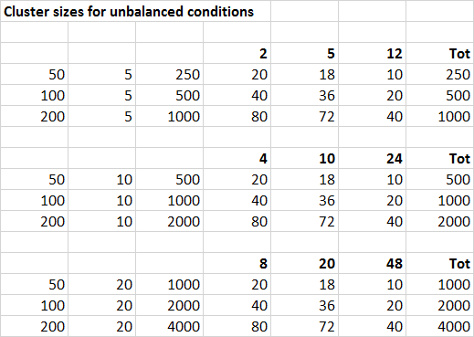

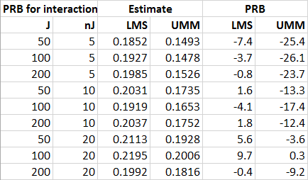

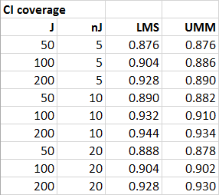 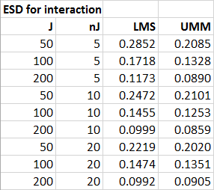

*Note*. ESD = empirical standard deviation.

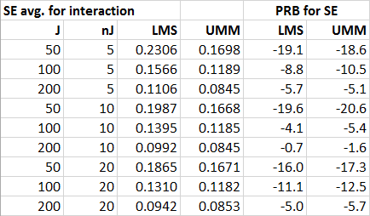

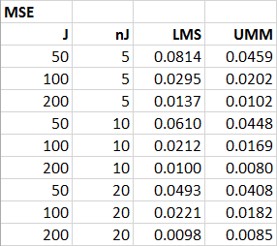

*Note*. MSE = mean squared error.

CI coverage is about the same as with balanced clusters. Bias, ESD, *SE*, and MSE were larger with unbalanced clusters for nearly all conditions. However, the relative performance of UMM and LMS remained the same: LMS showed less bias and more accurate coverage, while UMM was more efficient.

**Simulation 3**

In the third simulation, we compared LMS to using cluster means (UMM), but we changed the ICC of *xij* to .1 rather than .5. Furthermore, the current simulation was equated to the first simulation in all respects other than the ICC of *xij* by reparameterizing the model to contain standardized effects. This allowed us to use all the same parameter values across simulations, changing only the proportions of ‘within’ and ‘between’ variance in *xij*.

Number of clusters: 50, 100, 200

Cluster size: 5, 10, 20 (balanced)

Hypothesis: B2 (intxn of L2 variable with latent cluster mean of L1 variable)

ICCs: ICC = .1 for *xij*

Effect size: Interaction effect = .4472 (after rescaling)

Simulation reps: 500 per cell

We added another condition (*J* = 200, *nj* = 80) to examine what would happen under conditions of very large clusters. For each of the 20 cells of the design, we examined bias in the interaction effect and in the estimated standard error (mean estimated *SE* vs. the empirical standard deviation [ESD] of the estimate across reps). All runs converged for both LMS and UMM, with the exception of the *J* = 50, *nj* = 5 cell for LMS (494 out of 500 converged). The following tables summarize the results. For reference, the first table in each pair reports the results of the previous simulation, but note both simulations involved unstandardized effects that are necessarily different (.200 for the original simulation, and .447 for the new one).

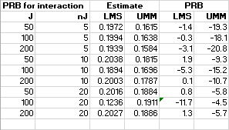 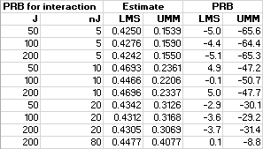

Note. PRB = percent relative bias; LMS = latent moderated structural equations; UMM = unconflated measured manifest means; *J* = number of clusters; *nJ* = cluster size.

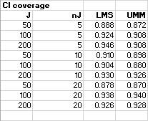 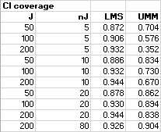

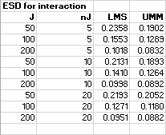 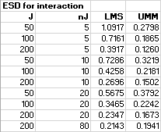

Note. ESD = empirical standard deviation.

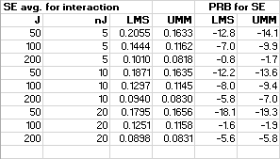 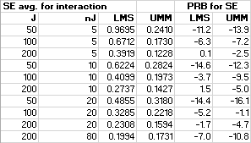

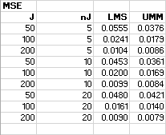 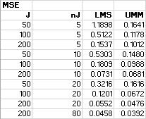

Note. MSE = mean squared error.

To summarize the results, as in the previous simulation, LMS is superior in terms of minimizing bias and achieving more accurate CI coverage. Across all conditions, the bias associated with UMM is unacceptably large. CI coverage is also unacceptably low for UMM in most conditions. Except for large cluster size conditions, UMM’s CI coverage gets worse as the number of clusters increases because the CIs become narrower around the more heavily biased point estimates.

UMM appears superior in terms of efficiency—although, as we note below, this does not translate into higher statistical power. This is partly due to the overall smaller effects, around which there is likely to be less uncertainty, and partly due to the fact that UMM’s *SE*s underestimate the ESDs more than does LMS in most conditions. UMM also appears superior in terms of MSE (the combination of bias and sampling variance); this is driven by the much smaller standard errors, which are able to compensate for the large bias.

In summary, there are stark differences between LMS and UMM in the limited conditions examined here. These differences can be seen as an example of the bias-variance trade-off. LMS minimizes bias at the cost of efficiency, which is reduced. UMM sacrifices unbiasedness in return for greater efficiency. In our view, the bias associated with UMM renders it unusable, whereas the inefficiency associated with LMS does not render it unusable (i.e., we consider bias to be more of a problem than uncertainty). Interestingly, the superior efficiency of UMM does not translate to markedly, or even uniformly, higher power:

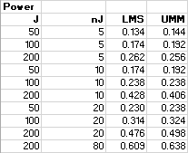

This is a telling result. If a researcher is trying to test a null hypothesis about the parameter, it may not matter much which method is used. If the researcher is trying to estimate the parameter, LMS gives much lower bias and more accurate CI coverage. This is an instance where lower MSE can be quite misleading about the quality of a method.